10.89: a) The initial angular momentum is 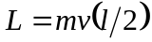 and the final moment of inertia
is 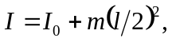 so

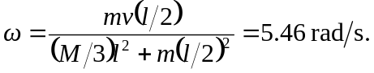

b) 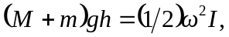and after solving for and substitution of numerical values, 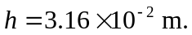 c) Rather than recalculate the needed value of , note that will be proportional to and hencewill be proportional to 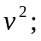 for the board to swing all the way over, 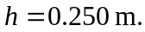and so 